Please include on: http://www.betanswers.com/

3 tips that will increase you chance of winning on horse racing
Horse racing is one of the oldest types of competitions known to mankind. The first traces of racing competitions including horses date back from ancient Egypt. In the past the most common type of race included a chariot, but it was extremely dangerous for the horse and the jokey and as time progressed rules and regulations started to appear and this form of racing was banned (at least in some regions around the world).

In our days the most common type of horse racing is a speed race on an oval circuit. This type of race is very common in England, Australia and Saudi Arabia. Hundreds or thousands of people gather at the horse racing track with their betting slips in the hand, hoping that their favorite will win.

Now thanks to the internet, this trend of going at the field is decreasing in popularity and people are opting for the online betting alternatives with live streaming.

But even if you understand the principles of betting, you may not know how to pick the perfect horse from the bunch and end up losing a couple of euros.

In this article i will share with you 3 tips that if followed right can bring you financial remuneration from won bets.

If at any point you have a question or did not understand something, leave a comment down below! I will try my best to explain as simple as possible, without technical terms.

Lets begin:

Tip number 1
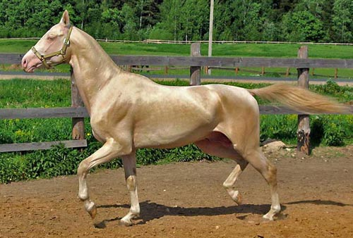
Always check the horse form and his history
- In order to be able to place a successful bet you must inspect a little bit the horses that are taking part in the competition. See their past history and verify their form (if you are watching a live streaming service , it is way easier, at least for the physical inspection). Pick a horse that its uniform in performance and has a pleasant appearance.

Tip number 2
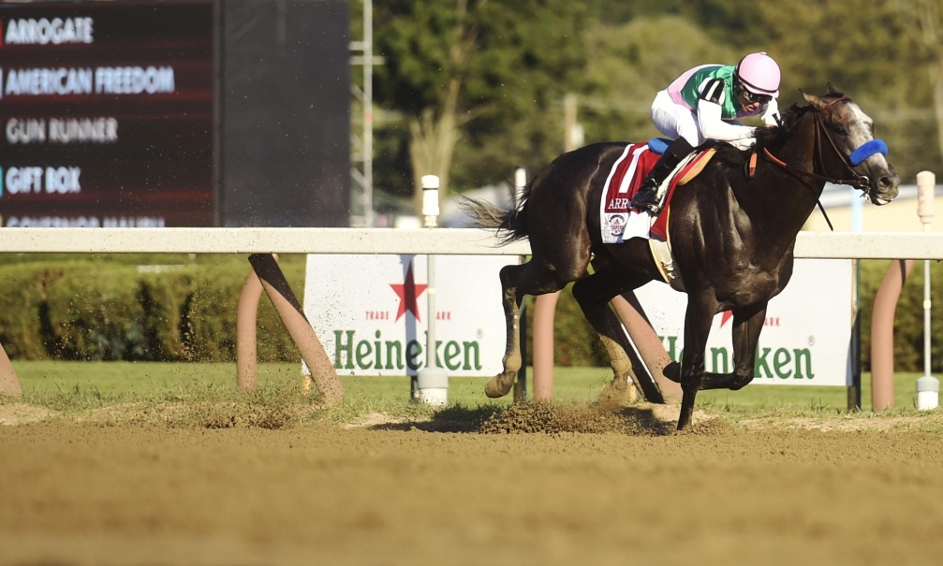
Don't always go with the favorite
- When a race is taking place a favorite is announced that usually has the lowest odd, but my advice is to not always go with the favorite (his top position is not always guaranteed). There is a very high chance that in the competition will take part 1 or maybe 2 horses with similar potential. Usually they are in 2th or 3th position in terms of odds.

Tip number 3
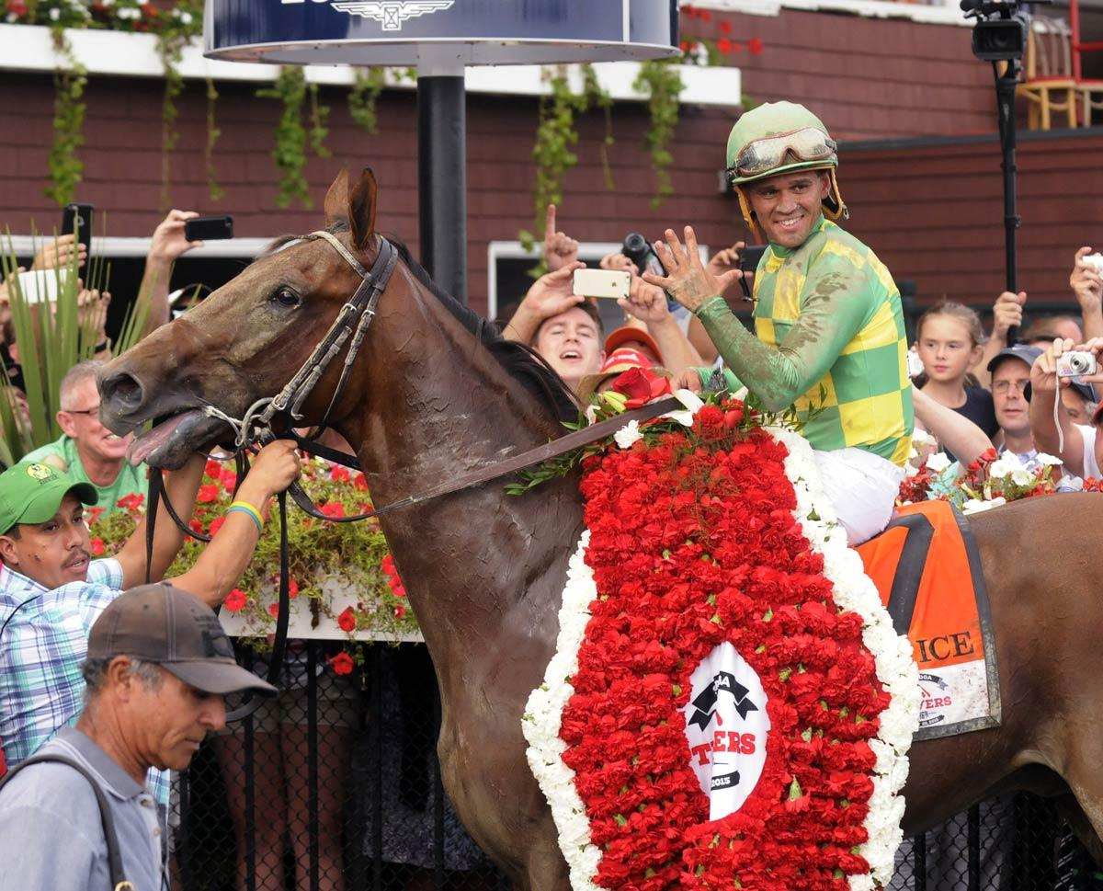
Look at the trainers and jockeys past
- The trainer and the jokey play a very important role in the horse's evolution. You might want to take a closer look at them to see how is their evolution over time. If you notice aascendant performance for both of them, then that horse may be the winner in your case.

The tips mentioned above do not guaranty by any means a win, but it will definitely help you achieve better results overall. Pay more attention to the details, analyze in advance the horses, jockeys and trainers and success may be upon you.

